**5 Best Star Gazing Apps**

Any sky or space lover is fascinated with various stars and planetary details. But the question is how one can know various stars, constellations, and other objects present in the sky? The Star Gazing applications are there to bring sky in front of you and with every detail about satellites, planets, stars, and constellations, in your mobile devices.

Amidst the COVID-19 pandemic, when most of the outdoor activities are restricted, relaxing and stress-busting is a difficult task that can be achieved effectively with the help of these Star Gazing applications. And, they can be used to enhance the knowledge about the sky and space. These applications are available for both Android as well as iOS, and these applications also have some augmented reality feature and have hundreds and thousands of detailing about various objects.

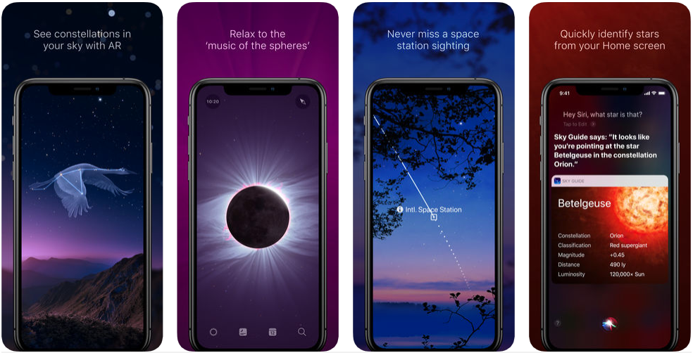

Being an astronomy genius is just a few clicks away with the help of these applications. Here are the top 5 applications for Star Gazing that will provide you proper information and fascination:

**NASA App:**

NASA is the most prominent space research organization and what can provide more details than the official NASA app? This application is available for both Android as well as iOS. This application provides fine detailing about several cosmos, and this also has articles, news, blogs, tweets, videos, and other contents that are provided by NASA. This application also provides live updates and pictures that come from NASA’s satellites. There is a consistent and constant update provided by the experts of NASA and that comes from the records of their researches.

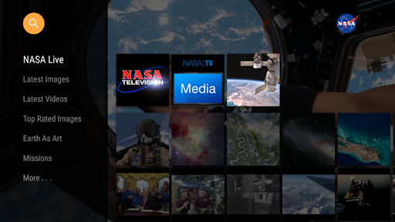

The application also has Earth Viewing experiments of High-Definition that are provided by ISS. NASA’s missions, experiments, and all other updates are there with this app too. This app has every feature that a Star Gazing lover might want.

**SkySafari:**

This is a more detailed information carrier and is the best application that can be used by professionals and researchers. The application also has a database of various information on stars, planets, and other celestial bodies, and all these details can be accessed offline with mobile devices. Historical, mythological, and scientific, all the stories related to various celestial bodies are available on this application to provide a detailed understanding and help become a specialist in the same.

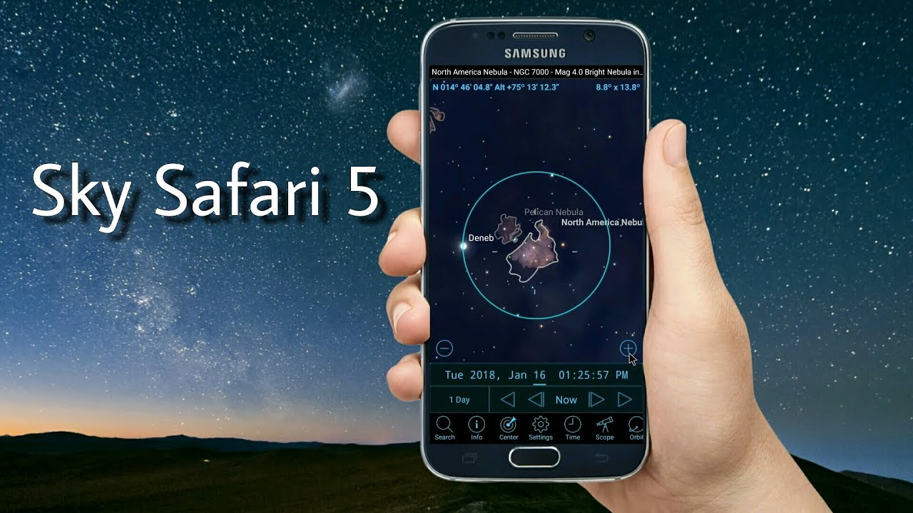

This is a free application that has several in-app purchases at $2.99 for added features and more detailing. SkySafari Plus and SkySafari Pro are the advanced versions of the application to have space tours with mobile devices. It also has a constellation illustration feature to help you visualize all the shapes that are related to them. Tonight’s Best is the feature that adds on to the fascination that this app provides by telling every information of the sky for the current day including all the details of the celestial bodies.

**International Space Station (ISS) app:**

This application is available for both Android as well as iOS. Internation Space station provides the details on various planets and the International Space station itself. This provides details about the location of the in-space laboratory in the world at that particular time. This app requires location permission that needs to be provided, and with that, it shows the expected time information about having a view of ISS.

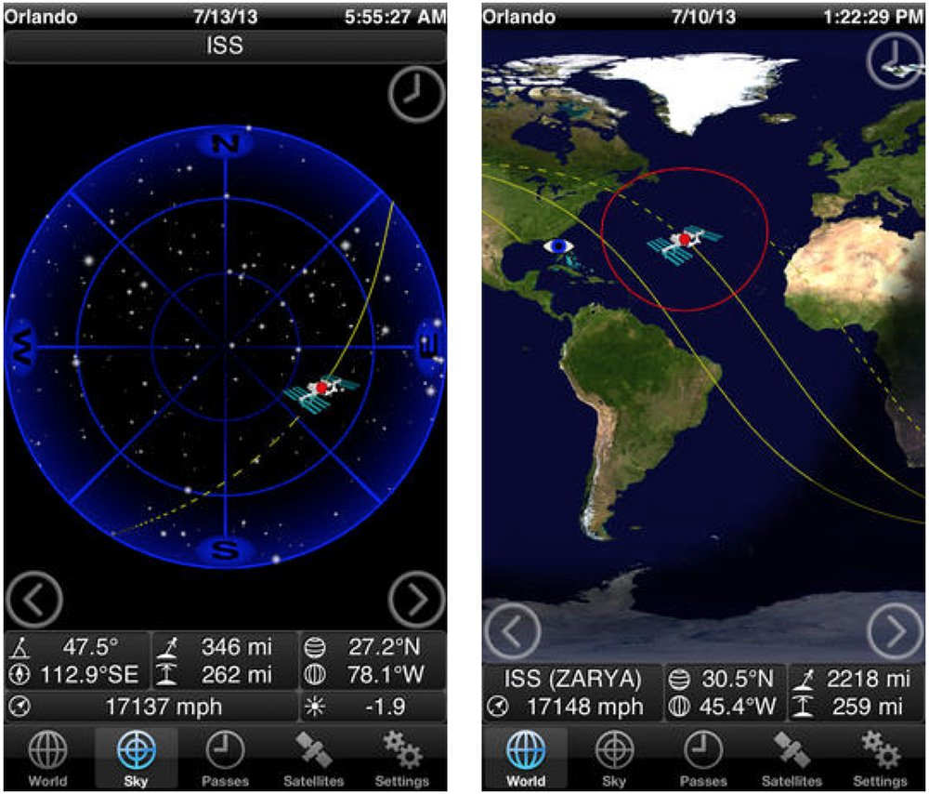

There is a particular time for every location from where ISS passes at a moment as it travels at 17,100 miles per hour, and that time is the perfect one to have a glance at it. The app provides detail about how long the passing will occur again and this helps to be prepared and free at that time to have that view.

**Star Walk 2:**

Star Walk is the application that uses augmented reality to display the details of several stars and planets. It has historical and mythological stories of the celestial bodies too. There is a time machine feature that informs about the past and future views of the sky. There is also a night view for clear stargazing experience and all these features ensure the highest fascination. The user interface of this application is highly attractive and admirable with simpler mechanics and several camera modes.

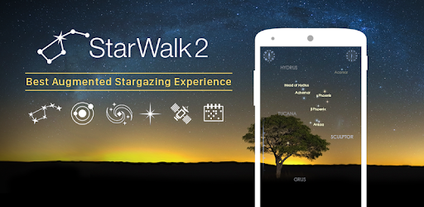

There is also a news feed in the application that informs about the latest and present astronomy news. This is a free application that adds-on to its advantages and has a few in-app purchases for enhanced experiences. Star Walks also has a version with appealing graphics for kids.

**SkyWiki**

SkyWalk has several embedded features including a GPS tracker to ensure best Star Gazing ever. There is also a calendar of celestial events and a compass to ensure better detailing. This application also has a periscope chart that provides details on sunrise and sunsets and also about altitude. Several features help to provide perfect orientation for viewing like crosshairs.

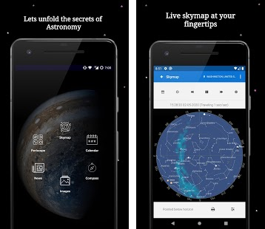

There are several facts present on the application about the sun, moon, and other planets. The features of the app are easy to use and require minimal actions for various activities. The app attracts astronomy lovers with the range of astronomical jargon that it uses. The app is going to release a new planetarium mode to attract more users and enhance its services.